Assignment 01 True error, relative error, percentage error, error analysis
Instructor: Madam Sadaf Saleem Subject: Numerical Analysis
Submitted by Batch 12, BE and BS Electrical
217-24481, Mohammad Abubakar Atiq
317-24482, Ahmed Azeem
317-24489, Hafiz Abdul Rehman
317-24491, Rafi-ullah
317-24494, Shuja Rehman
317-24494, Mian Hamza Usman
--------------------------------------------------------------------------------------------------------------------------
- True error:
The difference between the true solution value and the approximated (numerical) solution value,
ET=True value - Approximated value or,
$$E_{t}=true value-approximated value$$
- True relative error:
The percentage of the numerical error over the true value,
$$ϵ_{t}=\left|\frac{true value-approximated value}{true value}\right|*100\%$$
For some problem, the true solution is not known, calculations for a numerical solution are executed in an iterative manner until a desired accuracy is achieved, then estimated relative error is used as a standard to check the solution. The percentage of the difference between the current approximation and preceding approximation over preceding approximation is defined as approximation error,
$$ϵ_{a}=\left|\frac{current approximation-preceding approximation}{current approximation}\right|*100\%$$
Example 2.2:
Determine the true relative error and estimated relative error from approximating of $e^{0.5}$ by using the series $e^{x}=1+x+\frac{x^{2}}{2!}+\frac{x^{3}}{3!}+…$ up to 6th term. And write MATLAB code to display the all the true relative errors for each approximation.
True value:
>>format long; exp (0.5)
>>ans= 1.648721
1st term estimate:
2nd term estimate:
True relative error:
Estimated relative error:
Repeat for approximation to 3rd, 4th … term, we can get
Terms | Results | $$ϵ_{t}$$ | $$ϵ_{a}$$
 | 1 | 39.3
 | 1.5 | 9.02 | 33.3
 | 1.625 | 1.44 | 7.69
 | 1.645833333 | 0.175 | 1.27
 | 1.648437500 | 0.0172 | 0.158
 | 1.648697917 | 0.00142 | 0.0158

- Error analysis or error types

  - Inherent errors.
Errors that are present in the data that are input to the model are inherent errors. They are also called input error. They are classified into two- data errors and conversion errors.
  - Round off errors.
Specific quantities such as $π, or √2$ cannot be expressed exactly by a limited number of digits.
$$π=3.1415926535897932384626430$$
But computers can retain only a finite number of bits, thus chopping or rounding should be applied to the annoying long number.
Example: display $π$ in short, long and long scientific format with MATLAB.
Solution:
>>format short; pi
>>ans=3.1416 (short data has 5 digits)
>>format long; pi
>>ans=3.141492653589793 (long data has 16 digits)
>>format long e; pi
>>ans=3.141592653589793e+000 (long e data has 16 digits)
Error resulted from omission of the remaining significant figures is called round-off error.
Precision: all computations in MATLAB are done in double precision by default.
True value $π=3.141592653589793238462643….$
MATLAB pi=$3.141592653589793e+000$
The digits in the box have been rounded-off under MATLAB environment.

  - Truncation errors.
Truncation error: result from using numerical method (approximation) in place of an exact mathematical procedure to find the solution.
Example: The velocity with respect to time of bungee jumper is given in the 1st – order differential equation as below. Compute velocity of a free fall bungee jumper with a mass of 70kg. Use a drag coefficient of 0.25 kg/m.
$$\frac{dv}{dt}=g-\frac{C_{d}}{m}v^{2}$$
Where v = vertical velocity (m/s), t = time (s), g = gravity acceleration (@9.81$m/s^{2}$), $c_{d}=drag coefficient \left(\frac{kg}{m}\right), m={jumper}^{'}smass \left(kg\right).$
Analytical method:
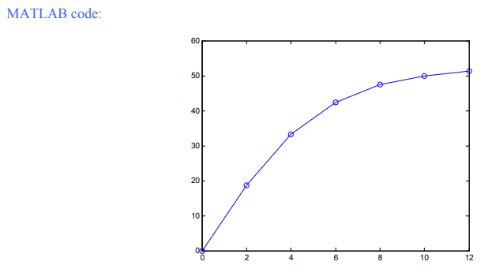
Numerical method:
Rate of change of velocity can be approximated by
$\frac{dv}{dt}=\frac{Δv}{Δt}=\frac{\left[v\left(t_{i+1}\right)-v\left(t_{i}\right)\right]}{t_{i+1}-t_{i}}$
$substitute\frac{dv}{dt}=g-\left(\frac{c_{d}}{m}\right)v^{2} into above to give$.
Rearrange equation to yield
Employ a step size $Δt=2 sec, @start t_{i}=0s, t_{i+1}=2s, v\left(0\right)=0m/s$
Next step $t_{i}=2s, t_{i+1}=4s, v\left(2\right)=19.62 m/s$
MATLAB CODE:
$$t(s)$$ | $$v(\frac{m}{s})$$
0 | 0
2 | 19.62
4 | 36.49
6 | 46.60
8 | 50.71
10 | 51.96
12 | 52.30

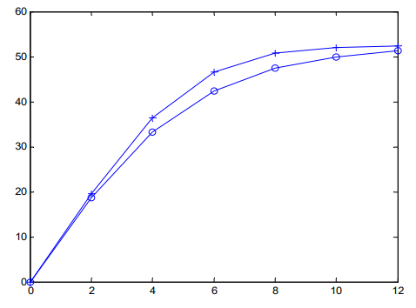
Another example:
Plot the Taylor series approximation of $f\left(x\right)=sin⁡(x)$ from n=1 to n=4 in MATLAB.
MATLAB code:
$$≫x=-2*pi:\frac{pi}{30}:2*pi;$$
>>y=sin(x); plot(x, y)
>>axis ([-2*pi 2*pi -1.5 1.5])
>>hold on
>>y1=x; plot(x, y1, ‘-o’)
>>y2=x-x. ^3/6; plot(x, y2, ‘:’)
>>y3=x-x.^3/6+x.^5/120; plot (x, y3, ’-x‘)
>> y4=x-x.^3/6+x.^5/120-x.^7/120/42; plot (x, y4, ’.-‘)
>>legend (‘sin(x)’, ‘n=1’,’n=2’, ‘n=3’, ‘n=4’)
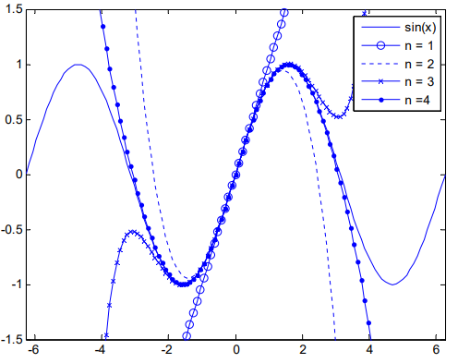
One last example,
Use Taylor series expansions with n=0 to 6 to approximate $f\left(x\right)=\cos\left(x\right)at x_{i+1}=π/3$ on the basis of the value of $f\left(x\right)and its derivatives at x_{i}=π/4$.
Solution:
Step size: h= True value $\cos\left(\frac{π}{3}\right)=0.5$
Zero-order approximation:
$$f\left(\frac{π}{3}\right)≈$$
First order approximation:
$$f\left(\frac{π}{3}\right)≈$$
Second order approximation:
$$f\left(\frac{π}{3}\right)≈$$
The process can be continued and the results listed as in

Order n | $$f(\frac{π}{3})$$ | $$|ϵ_{t}|(\%)$$
0 | 0.707106781 | 41.4
1 | 0.521986659 | 4.40
2 | 0.497754491 | 0.449
3 | 0.499869147 | 2.62*10^-2
4 | 0.500007551 | 1.51*10^-3
5 | 0.500000304 | 6.08*10^-5
6 | 0.499999988 | 2.44*

  - Absolute errors.
Definition:
Absolute error is the difference between measured or inferred value and the actual value of a quantity. The absolute error is inadequate due to the fact that is does not give any details regarding the importance of the error. While measuring distances between cities kilometers apart, an error of a few centimeters is negligible and is irrelevant. Consider another case where an error of centimeters when measuring small machine parts is a very significant error. Both the errors are in the order of centimeters but the second error is more severe than the first one.
Absolute error formula:
If x is the actual value of a quantity and $x_{0}$ is the measured value of the quantity, then the absolute error value can be calculated using the formula,
$$Δx=x-x_{0}.$$
$$here, Δx is called an absolute error.$$
If we consider multiple measurements, then the arithmetic mean of absolute errors of individual measurements should be the final absolute error.
Absolute error example:
For example, 24.13 is the actual value of a quantity and 25.09 is the measure or inferred value, then the absolute error will be:
Absolute error = 25.09-24.13=0.86
Most of the time it is sufficient to record only two decimal digits of the absolute error. Thus, it is sufficient to state that the absolute error of the approximation 4.55 to the correct value 4.538395 is 0.012.
  - Relative errors.
The relative error is defined as the ratio of the absolute error of the measurement to the actual measurement. Using this method we can determine the magnitude of the absolute error in terms of the actual size of the measurement. If the true measurement of the object is not known, then the relative error can be found using the measured value. The relative error gives an indication of how good measurement is relative to the size of the object being measured.
If x is the actual value of a quantity, $x_{0}$ is the measured value of the quantity and $Δx$ is the absolute error, then the relative error can be measured using the below formula.
$$relative error=\frac{x_{0}-x}{x}=\frac{Δx}{x}$$
An important note that relative errors are dimensionless. When writing relative errors it is usual to multiply the fractional error by 100 and express it as a percentage.
Absolute error and relative error in numerical analysis:
Numerical analysis is concerned with the methods of finding the approximate values and the absolute errors in these calculations. The absolute error gives how large the error is, while the relative error gives how large the error is relative to the correct value. In numerical calculation, error may occur due to the following reasons.
- Round off error.
- Truncation error.
Example 1:
Find the absolute and relative errors of the approximation 125.67 to the value 119.66.
Solution:
Absolute error=|125.67-119.66|=6.01
Relative error=|125.67-119.66|/119.66=0.05022
Mean Absolute error:
The mean absolute error is the average of all absolute errors of the data collected. It is abbreviated as MAE (Mean Absolute error). It is obtained by dividing the sum of all the absolute errors with the number of errors. The formula for MAE is:
$$MAE=\frac{1}{n}Σ_{i=1}^{n}|x_{i}-x|$$
Here, n is number of errors.
  - Percentage errors.
Percent errors indicate how big our errors are when we measure something in an analysis process. Smaller percent errors indicate that we are close to the accepted or original value. For example, a 1% error indicates that we got very close to the accepted value, while % means that we were quite a long way off from the true value. Measurement errors are often unavoidable due to certain reasons like hands can shake, material can imprecise, or our instruments just might not have the capability to estimate exactly.
Percent error formula:
The formula for percent error is:
PE= (|Estimated value-Actual value|/Actual value) x 100
Or
$$\%error=\left|\frac{T-E}{T}\right|*100$$
Here,
T = true or actual value, and E = estimated value.
Percent error of mean:
Percent error mean or mean percentage error is the average of all percent errors of the given model. The formula for mean percentage error is given by:
$$MPE=100\%\frac{1}{n}\sum_{i=1}^{n}{\frac{\left|T_{i}-E_{i}\right|}{T_{i}}}$$
Here,
$$T_{i}=true or actual value of ith quantity,$$
$$E_{i}=estimated value of ith quantity,$$
$$n=number of quantities in the model.$$
The main disadvantage of this measure is that it is undefined, whenever a single actual value is zero.
Percent error example:
Question no.1:
A boy measured the area of a rectangle plot to be $468cm^{2}.$but the actual area of the plot has been recorded as $470cm^{2}.$ Calculate the percent error of his measurement.
Solution:
Given data is,
$measured area value=468cm^{2}$.
$actual area value=470cm^{2}$.
Steps of calculation:
Step 1: subtract one value from another; 468-470=-2
By ignoring the negative sign, the difference is 2, which is the error.
Step 2: Divide the error by actual value; 2/470=0.0042531
Multiply this value by 100; 0.0042531*100=0.42% (expressing it in two decimal points) hence, 0.42% is the percent error.
--------------------------------------------------------------------------------------------------------------------------
References links:
- Absolute and Relative Error- Definition, Formulas, and Examples (byjus.com)
- Practice problems -1 (mun.ca)
- Microsoft PowerPoint - Lecture 8 Errors in Numerical Methods.pptx (tamu.edu)
- Percent Error - Definition, Formula, and Solved examples (byjus.com)
- Errors and Approximations in Numerical Methods – NotesPoint

